# 

# **Department of Computer Science and Engineering Islamic University of Technology (IUT)** A subsidiary organ of OIC

# 

# **Laboratory Report**

# CSE 4412: Data Communication and Networking Lab

## **Name: Md Muktadir Mazumder Student ID: 190042136 Section: Group B Semester: 4th Semester Academic Year: 2021-22**

**Date of Submission:14.03.22**

### **Title:** Configuration of OSPF in a network topology.

### **Objective**:

1. Understand Link State Routing Protocol
2. Understand OSPF
3. Understand the difference between DV and LS routing

### **Devices/ software Used**:

1. Device: Personal Computer

2. Software: Cisco Packet Tracer

### **Theory:**

**Link State (LS) Routing**

The basic concept of link-state routing is that every node constructs a map of the connectivity to the network, in the form of a graph, showing which nodes are connected to which other nodes. Each node independently calculates the next best logical path from it to every possible destination in the network. Each collection of best paths will then form each node's routing table. In this Routing Protocol, the router attempts to construct its own internal map of the network topology. It provides the information about whether the link to reach the router is active or not. Every router will create something called Link state packets.

**Link-State Database (LSDB)**

The Link State Database is the database that OSPF builds and is based on the information that it has found in LSAs (Link State Advertisements). The LSDB is synchronized between routers within the same area.

**Link State Packet**

Link State Packet (LSP) is a packet of information generated by a network router in a link state routing protocol that lists the router's neighbors. Link state packets can also be defined as special datagrams that determine the names of and the cost or distance to any neighboring routers and associated networks. They are used to efficiently determine what the new neighbor is, if a link failure occurs, and the cost of changing a link if the need arises.They can be distributed throughout the network, but cannot use the routing database.

**Least cost tree formation step by step (use more than three nodes)**

Prim's algorithm to find minimum cost spanning tree uses the greedy approach. Prim's algorithm shares a similarity with the shortest path first algorithms

***Using Prim's Spanning Tree Algorithm:*** We have taken the following image to explain least cost tree formation --

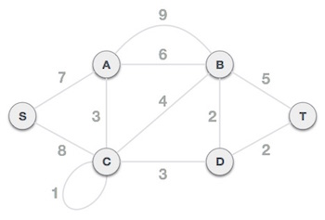

***Step 01 -*** *Remove all loops and parallel edges*

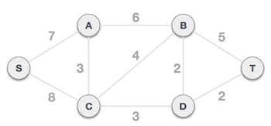

***Step 02* -** *Choose any arbitrary node as root node*

***Step 03* -** *Check outgoing edges and select the one with less cost*

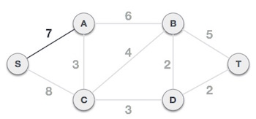

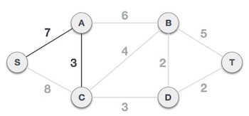

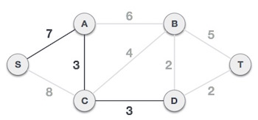

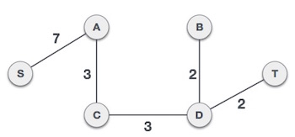

**Open Shortest Path First (OSPF)**

The OSPF stands for **Open Shortest Path First**. It is a widely used and supported routing protocol. It’s one of the family of IP Routing Protocols and is an Interior Gateway Protocol for then internet. It’s used to distribute IP Routing information throughout a single Autonomous System is an IP network.

**Metric:**

The OSPF metric for a route is the sum of the interface costs for all outgoing interfaces in the route. By default, a router’s OSPF interface cost is actually derived from the interface bandwidth. The faster the bandwidth, the lower the cost. A lower OSPF cost means that the interface is better than an interface with a higher OSPF cost.

**Areas:**

OSPF network can be divided into sub-domains, called areas. An area is a logical collection of OSPF networks, routers, and links that have the same area identification. A router within an area must maintain a topological database for the area to which it belongs. The router does not have detailed information about network topology outside of its area, for which it reduces the size of its database.

**Link State Advertisement (LSA):**

Link-state advertisement is a basic communication means of the OSPF routing protocol for the Internet Protocol (IP). It communicates the router's local routing topology to all other local routers in the same OSPF area and is designed for scalability that’s why LSAs are not flooded out on all interfaces.Only those are flooded that belong to the appropriate area. In this way detailed information can be kept localized, while summary information is flooded to the rest of the network

**OSPF Implementation:**

To enable OSPF on the Cisco router and advertise interfaces, the following tasks are needed to complete:-

Task 01: Use the command router OSPF process ID to start the OSPF.

Task 02: Then use the network command to enable the interfaces.

Task 03: Identify the area assignments.

Task 04: Assign the router ID(optional).

### **Performance:**

Unlike the RIP protocol which has only fifteen hops at most,But the OSPF has no limitations on the hop count. Therefore the OSPF converges faster than RIP, and has better load balancing.

**Update Message:**

* **Hello:** These messages are used as a form of greeting, to allow a router to discover other adjacent routers on its local links and networks. And used to discover, build, and maintain OSPF neighbor adjacencies. To establish adjacency, OSPF peers at both sides of the link must agree on some parameters contained in the Hello message to become OSPF neighbors.
* **Database Description (DBD) :** These messages contain descriptions of the topology of the AS or area. That is, they convey the contents of the link-state database for the autonomous system or area from one router to another. Communicating a large LSDB may require several messages to be sent; this is done by having the sending device designated as a master device and sending messages in sequence.
* **Link-State Request (LSR)** : These type of messages are used by one router to request updated information about a portion of the LSDB from another router. The message specifies exactly which link(s) about which the requesting device wants more current information.
* **Link State Update:**These messages contain updated information about the state of certain links on the LSDB. They are sent in response to a Link State Request message, and also broadcast or multicast by routers on a regular basis. Their contents are used to update the information in the LSDBs of routers that receive them.
* **Link-State Acknowledgment**: These messages provide reliability to the link-state exchange process, by explicitly acknowledging receipt of a Link State Update message.

**Convergence of Forwarding Tables:**

Convergence is the state of a set of routers that have the same topological information about the internet-work in which they operate. For a set of routers to have converged, they must have collected all available topology information from each other via the implemented routing protocol. In a converged network all routers "agree" on what the network topology looks like.The state of convergence is achieved once all routing protocol-specific information has been distributed to all routers participating in the routing protocol process. Any change in the network that affects routing tables will break the convergence temporarily until this change has been successfully communicated to all other routers.

### **Diagram of the experiment:**

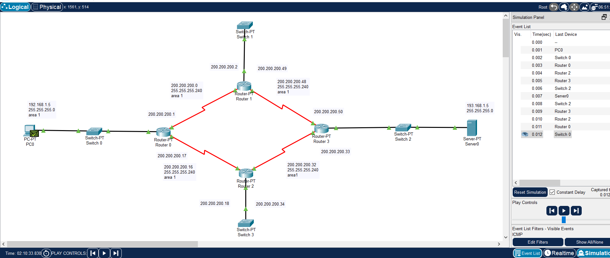

### **Configuration of Routers:**

Commands for configuring OSPF

**For Router 0:**

#en  
#router ospf 1  
#network 192.168.1.5 0.0.0.255 area 1

#network 200.200.200.0 0.0.0.15 area 1

#network 200.200.200.16 0.0.0.15 area 1

**For Router 1:**

#en

#router ospf 1  
#network 200.200.200.0 0.0.0.15 area 1

#network 200.200.200.48 0.0.0.15 area 1

**For Router2:**

#en  
#router ospf 1  
#network 200.200.200.16 0.0.0.15 area 1

#network 200.200.200.32 0.0.0.15 area 1

**For Router3:**

#en  
#router ospf 1  
#network 200.200.200.48 0.0.0.15 area 1

#network 200.200.200.32 0.0.0.15 area 1

#network 193.168.1.0 0.0.0.255 area 1

### **Observation**:

The screenshots of routing table of each router is shown below:

**Routing Table for Router 0:**

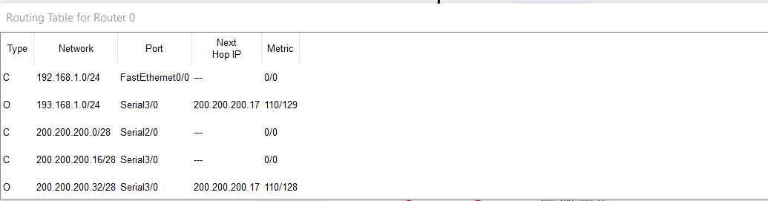

**Routing Table for Router 1:**

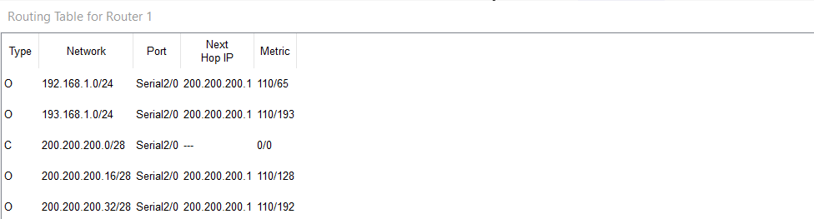

**Routing table for Router 2:**

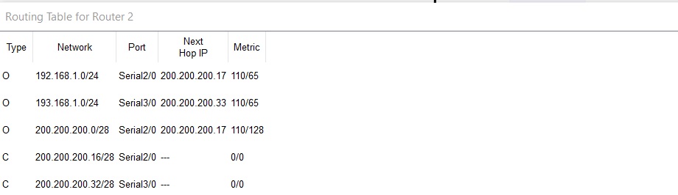

**Routing Table for Router 3:**

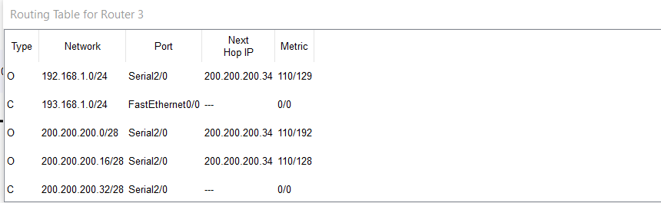

### **Challenges:**

Alhamdulillah the experiment was done successfully. It was very difficult to understand the theory and usage of subnet mask and faced difficulty during assigning the default gateway.

### 